**Prof. Joris Thybaut** is a Senior Full Professor in Catalytic Reaction Engineering (CaRE) within the Laboratory for Chemical Technology at Ghent University since (first appointed in 2005) and is the director of Chemical Engineering and Materials Sciences programs in the Faculty of Engineering and Architecture. He went to the 'Institut des Recherches sur la Catalyse' in Lyon, France, for a postdoc on high throughput experimentation in 2003, performed an industrial sabbatical with Shell (Amsterdam, 2010) and served as visiting professor at the Japanese Advanced Institute for Science and Technology in the period 2020-2021. In 2014 he received a prestigious ERC consolidator grant for model based catalyst design for the conversion of renewables into chemicals and fuels. Among others thanks to the proof-of-concept grant PR1ME the first principles based modelling methodology for hydrotreatment is now being commercialized. Prof. Thybaut chaired CAMURE 12 & ISMR 11 held in Ghent in September 2024 and has regularly been organizing seasonal schools on kinetics and reactors, either open towards the academic and industrial community or, in case upon invitation, for large-scale industrial companies. He is also member of the ACS Engineering Au editorial board and one of the leading academics in the Eurokin consortium on kinetics and reactors (www.eurokin.org). Research projects range from bilateral contracts with industrial partners up to government funded large scale integrated projects, either as PI (DELICARE, NEXT-STEP, COP-CAT, NextBioRef,…) or coordinator (e-CODUCT, GREEN-B2B, OBIWAN…). His research activities evidence a steady evolution from more classical refining reactions to renewables valorisation. Most recently, as part of bilateral collaborations the scope of the investigated chemistry is further being extended towards inorganic reactions, pharmaceutical applications and circular chemistry.

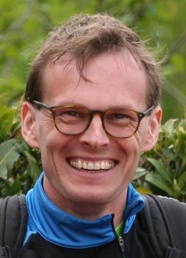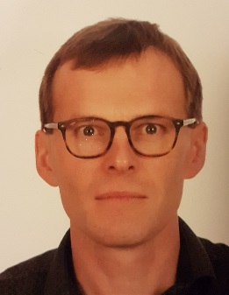Joris W. Thybaut (°1975, Ghent Belgium) is full professor in catalytic reaction engineering at the Laboratory for Chemical Technology at Ghent University since October 2014. He obtained his master's degree in chemical engineering in 1998 at the same university, where he continued his PhD studies on single-event microkinetic (SEMK) modeling of hydrocracking and hydrogenation. In 2003 he went to the 'Institut des Recherches sur la Catalyse' in Lyon, France, for a postdoc on high throughput experimentation, before being appointed in 2005 at Ghent University.

Today, prof. Thybaut is heading the Catalytic Reaction Engineering (CaRE) research group, comprising about 15 junior researchers and post-docs, within the Laboratory for Chemical Technology at Ghent University. Prof. Thybaut and his group actively investigate a variety of large-scale industrial reactions and more particularly, the rational design of the corresponding catalysts as well as of the reactors in which the corresponding reactions are exploited. Ideal gas phase reactions as well as strongly non-ideal liquid phase reactions are addressed. Research projects range from bilateral contracts with industry up to government funded large scale integrated projects. Prof. Thybaut holds an ERC consolidator grant to innovate the SEMK methodology and use it in the framework of renewable, oxygen containing feeds. More recently, as part of bilateral collaborations the scope of the investigated chemistry is further being extended towards inorganic reactions.